## Vivekanand Education Society’s Institute of Technology

## Department of Computer Engineering

## TIFR - VESIT Projects

## **Minutes of Meeting**

**Venue: TIFR, Colaba**

**Date: 30th March 2024 Time: 11 AM to 2 PM**

**Participants Attendance List:**

* **Mr. Pruthvi - Department of High Energy Physics, TIFR**
* **Mr. Figo Cardozo - BE, Computer Engineering, VESIT**
* **Ms. Drishti Samvedi - BE, Computer Engineering, VESIT**
* **Mr. Om Madat - BE, Computer Engineering, VESIT**
* **Mr. Vansh Pahuja - BE, Computer Engineering, VESIT**
* **Mr. Tanay Phatak - BE, Computer Engineering, VESIT**
* **Mr. Tanmay Thakre - BE, Computer Engineering, VESIT**
* **Mr. Gautam Wadhwani - BE, Computer Engineering, VESIT**

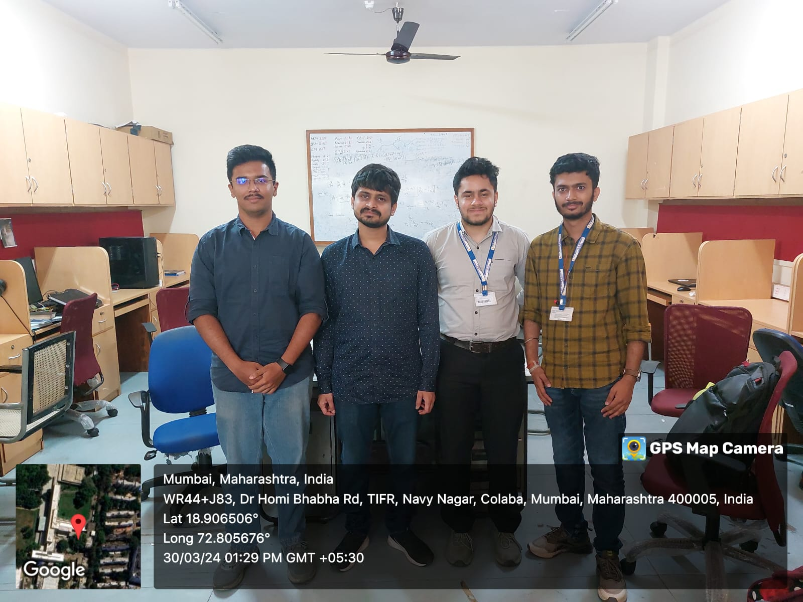 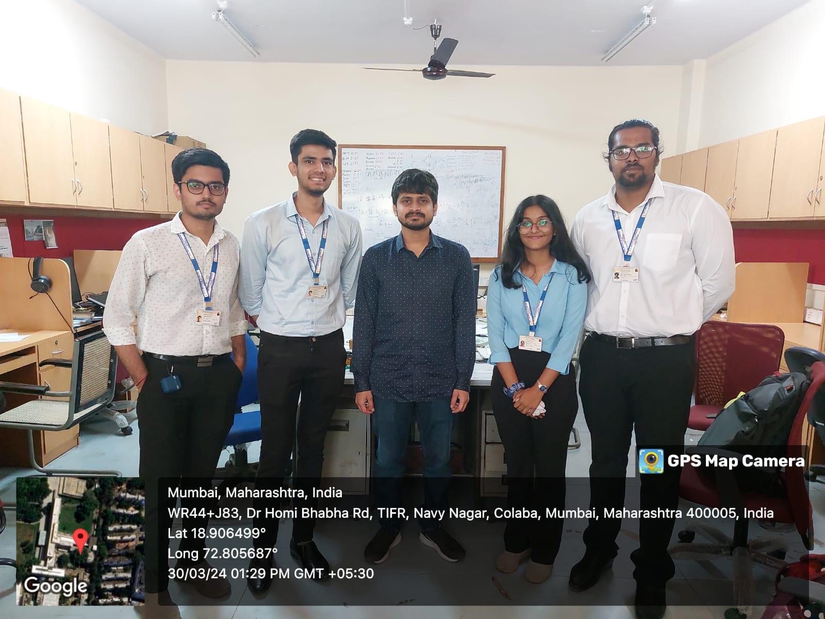

**Agenda:**

* To present the work done since the previous meeting and share the progress.
* Plan further work to be done based on the suggestions given.

**Points Discussed:-**

**Missing Substance Detection:**

1. Got the package installation issues resolved.
2. Tested the implementation in TIFR machines for performance enhancements.

**Remote Access Control:**

1. Presentation of Entire project
2. Demonstration of Implementation
3. Project Approved by Pruthvi Sir
4. Pruthvi Sir also asked about the internal working of the libraries used which was answered by the students.